## If you are a windows user, this might help you.

**Installing Ubuntu on Virtual PC on Windows**

* Download this virtual software : <https://www.virtualbox.org/>
* Download this iso : <http://releases.ubuntu.com/18.04/ubuntu-18.04-desktop-amd64.iso.torrent>
* Instructions to install iso on virtual software: <https://www.youtube.com/watch?v=iThHGPX7bPs>

# If you are getting issue such as not getting 64 bit option while installing iso on virtual software on 64 bit PC. These links might help you : <https://www.youtube.com/watch?v=ojkF4iYlYqc>

<https://www.youtube.com/watch?v=-Wa7TGjmn5M>

* Instructions to install julia :

Run these command in terminal

sudo apt install vim

sudo vim ~/.bashrc

Enter the password

Press i to enter the insert mode.

After the bashrc terminal open to insert the path of Julia exe file, enter the path of julia as shown in the figure below.

PATH=$PATH:path

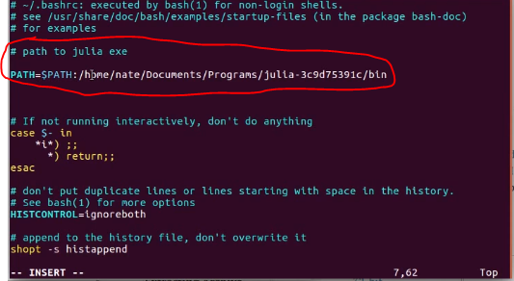

Press esc to go out of the insert mode.

Enter :wq to write the code and exit.

Now open the new terminal and enter julia to open julia

For more help, see the video : <https://www.youtube.com/watch?v=PCuobcwJhhc>

**Installing Julia**

* Download : <https://julialang-s3.julialang.org/bin/linux/x64/0.6/julia-0.6.3-linux-x86_64.tar.gz>
* Extract the downloaded file
* Install using Terminal

**After installing Julia in Ubuntu**

Install the following packages : CSV.jl, DataFrames.jl, TensorFlow.jl

* Use Pkg.add(“CSV”) to add the package
* To use the package use the command : using CSV
* Do the same for other packages

**Common ERROR while installing TensorFlow package**

Most common errors are :

LoadError: could not spawn `make USE_DSFMT=1 DSFMT_includedir=/root/.julia/v0.6/Rmath/deps/dSFMT DSFMT_libdir=/usr/local/julia/bin/../lib/julia`: no such file or directory (ENOENT)

Reason for the error : : build-essential was missing

To resolve this issue run these command In the terminal.

RUN apt-get update && apt-get install -y build-essential \  
 && julia -e 'Pkg.update(); Pkg.add("Rmath")'

Run same command for HDF5 package

RUN apt-get update && apt-get install -y build-essential \  
 && julia -e 'Pkg.update(); Pkg.add(“HDF5")'

Reference : https://github.com/JuliaStats/Rmath.jl/issues/34